**DLD Lab 12**

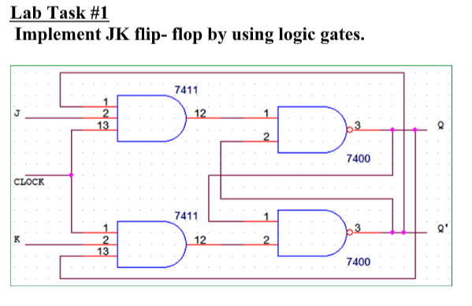

|  |  |  |  |  |  |
| --- | --- | --- | --- | --- | --- |
| J | K | CLK | Q | Q’ | Comments |
| X | X | NOT | Q | Q’ | Latched |
| 0 | 0 |  | Q | Q’ | No change |
| 0 | 1 |  | 0 | 1 | RESET |
| 1 | 0 |  | 1 | 0 | SET |
| 1 | 1 |  | Q’ | Q | Toggle |

Q2) Implement D Flipflop by using logic gates.

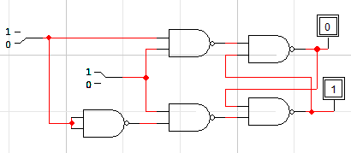

|  |  |  |  |  |
| --- | --- | --- | --- | --- |
| D | CLK | Q | Q’ | Comments |
| X | 0 | Q | Q’ | No change |
| 0 | 1 | 0 | 1 | RESET |
| 1 | 1 | 1 | 0 | SET |

Q3) Implement JK FF using NOR gate.

